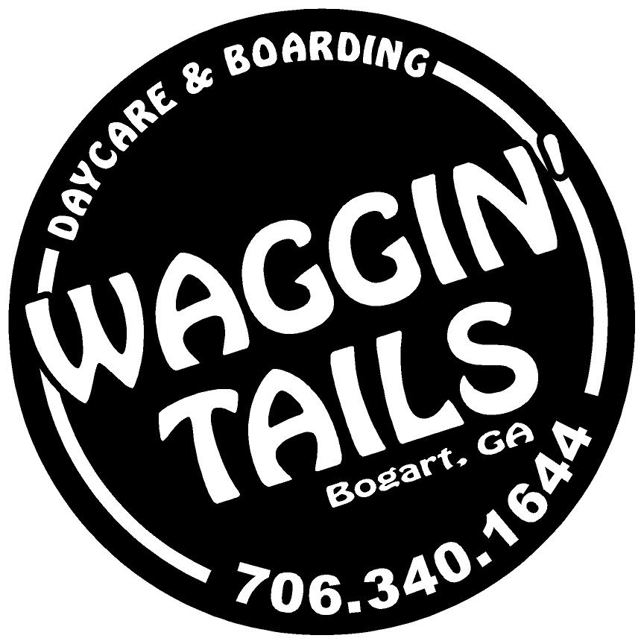
Waggin Tails
Obedience Training

1379 Savage Road
Bogart, GA 30622
(706) 340 1644

www.waggintailsbogart.com

Overview
Waggin Tails is proud to offer an immersive two-week board and train option to our customers. We sit down with every customer, and their dog, to develop a customized training plan specific to the constitution of the dog and the desires of the owner. Our trainer then spends two weeks utilizing motivation driven methods to encourage desired actions while alleviating undesirable behaviors. This makes learning fun for the dog, and makes them want to work.

Schedule
Your dog will be dropped off on a Friday, and picked up two Saturdays later. Upon completion of the program, your dog will have a graduation ceremony where we do a 1 hour handover session to train the owners on what the dog has learned. You will also schedule a 1 hour in home session for approximately two weeks later to address any place association issues that may arise once your dog returns home. Below is the timeline for your pets training.

 |  |  |  |  | Friday Acclimation Day | Saturday Rapport Day
Sunday Rapport Day | Monday Training Day | Tuesday Training Day | Wednesday Training Day | Thursday Training Day | Friday Training Day | Saturday Flex Day
Sunday  Rest Day | Monday Training Day | Tuesday Training Day | Wednesday Training Day | Thursday Training Day | Friday Training Day | Saturday Graduation

Please note that training plans can change during training and this is simply a baseline. You can expect updates via email every Wednesday from your trainer to discuss progress and any adjustments that may need to be made in training.

Pricing
Beginners Course ($1250) Sit, Stay, Heel, Touch, Leash Control
Advanced Course (VARIES) Custom Designed Training Plan
Personal Training ($75 per hour) Additional fees if we travel to your location

FAQ’s

Do you use shock collars?
This is probably the most commonly asked question, and the short answer is no. Most “shock collars” are actually “E-Collars” that emit a vibration or sound and not an actual shock. All of our training is done on a leash and flat collar. This ensures that the dog is trained on what the owner will be utilizing, and creates results that last a lifetime by using the safest and most effective methods.

Does my dog have to stay with you?
Yes. It is imperative that the dog focuses on our trainer only during the training imprintation phase. Consistency is key during this time, and our trainers know how to effectively shape the desired behaviors. Any deviation from these parameters will stall or reverse training costing us more time and you more money. Trust us, it will be worth the wait once you see how much your dog has learned!

Can you guarantee my dogs training?
We can guarantee that we will get your dog where you want it. Just like humans, every dog is different and learns at a different pace. Our trainers utilize a number of techniques to adjust training to the learning style and motivational drive factors to maximize training efforts. Two weeks is plenty of time to set the groundwork, but the only way to guarantee your dogs success is to continue the training maintenance once they get home. It is imperative that YOU set the standards of expectations in the first few weeks your dog is back home. We will provide you with the tools to be successful, but the only way to guarantee your money was well spent is to utilize the tools we provide.

How do I get started?
To schedule a consultation, head over to www.waggintailsbogart.com. Set up a profile if you do not have one already. Select the drop down menu below the “appointments” tab and select “training consultation”. You can then select the day and time you want to bring your dog by to meet our trainers and discuss how we can get your dog where you want them to be! See you soon!

